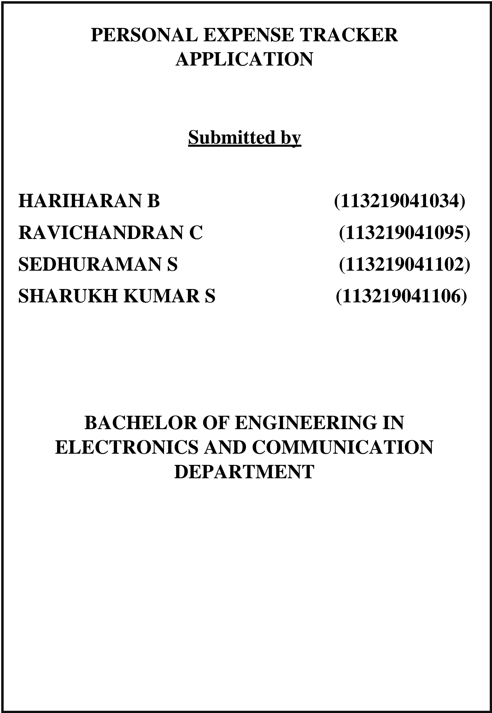

**Project Design Phase-I**

**Proposed Solution Template**

|  |  |
| --- | --- |
| Date | 30 September 2022 |
| Team ID | PNT2022TMID23493 |
| Project Name | Project – Personal Expense Tracker Application |
| Maximum Marks | 2 Marks |

**Proposed Solution Template:**

Project team shall fill the following information in proposed solution template.

|  |  |  |
| --- | --- | --- |
| **S.No.** | **Parameter** | **Description** |
|  | Problem Statement (Problem to be solved) | * Budgeting problems in day to day life. * Clueless about where your money goes. * Non proper maintenance of billing. |
|  | Idea / Solution description | * Helps keep track of your expenses. * Helps in managing your finances efficiently. * Analysis of expenditure in graphical forms. |
|  | Novelty / Uniqueness | * It uses cloud database for efficient and long time storage. * Graphical analysis makes comparison easier. * Alerts the user if expense reaches certain user-given limit. |
|  | Social Impact / Customer Satisfaction | * Easier user interface. * Easy access to common people. * Data can be accessed anywhere at anytime. |
|  | Business Model (Revenue Model) | * Get approval to publish/release in playstore. * Targets audience who needs help in expense management. |
|  | Scalability of the Solution | The project will be completed within six months of time and will be available for public use as soon as possible. |